**RDBMS LAB - 02**

NAME- Ragini Sharma

ID- B120062

1. **SELECT - FROM -GROUP BY: This query is used to group to all the records in a relation together**

**for each and every value of a specific key(s) and then display them for a selected set of fields**

**the relation. (First insert few records w.r.t. itemname into the CUSTOMER table)**

**Syntax: SELECT a set of fields FROM relation_name GROUP BY field_name;**

**Example: SQL> SELECT CID, SUM (PRICE) FROM CUSTOMER GROUP BY ITEMNAME;**

Example 1:

Code-

CREATE TABLE Customer(CID INT, Name VARCHAR(20), PRICE INT); (Created table Customer)

INSERT INTO Customer

VALUES(20, "Raj", 2000), (89, "Mohan", 100), (78, "Shaktimaan", 5000); (Inserted 3 records into Customer)

SELECT CID, SUM(PRICE) FROM Customer GROUP BY Name; (grouped to all the records in the relation together

for each and every value of a specific key(s) and then displayed them for a selected set of fields in the relation)

Output-

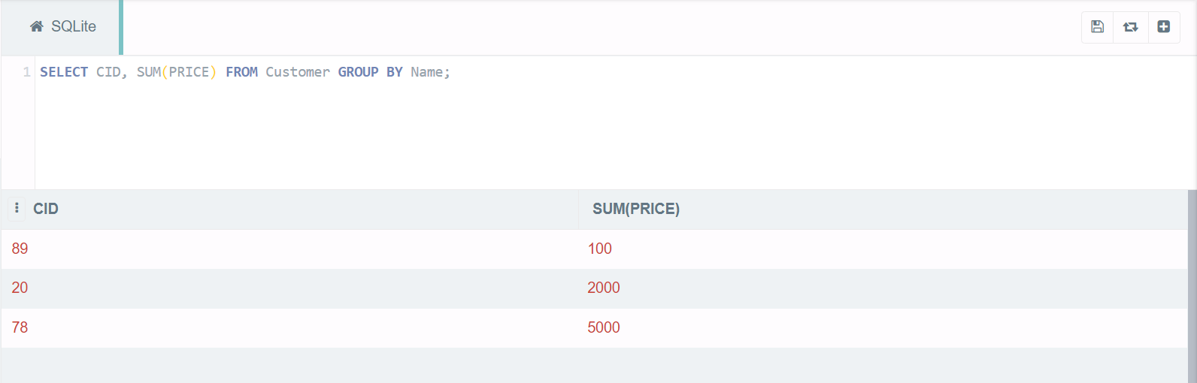

Example 2:

Code-

CREATE TABLE Marvel(age INT, name VARCHAR(30), avenger VARCHAR(30), soloMovies INT); (Created table Marvel)

INSERT into Marvel

VALUES(48, "Tony Stark", "Iron Man", 3), (93, "Steve Rogers", "Captain America", 3), (32, "Natasha Romanoff", "Black Widow", 1), (47, "Clint Barton", "Hawkeye", 0); (Inserted 4 records into Marvel)

SELECT avenger, SUM(solomovies) FROM Marvel GROUP BY name; (grouped to all the records in the relation together for each and every value of a specific key(s) and then displayed them for a selected set of fields in the relation)

Output-

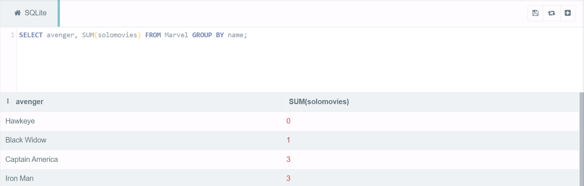

1. **SELECT - FROM -ORDER BY: This query is used to display a selected set of fields from a relation**

**in an ordered manner base on some field.**

**Syntax: SELECT a set of fields FROM relation_name ORDER BY field_name;**

**Example: SQL> SELECT SNAME,SUBJ1 FROM STUDENTS ORDER BY ROLL;**

Example 1:

Code-

CREATE TABLE Students(ROLL INT, SNAME VARCHAR(20), SUBJ1 INT); (Created table Students)

INSERT INTO Students

VALUES(1, "Aryan", 98), (17, "Peter", 67), (66, "Joshua", 88); (Inserted 3 records into Students)

SELECT sname, subj1 FROM Students ORDER BY roll;(displayed a selected set of fields from a relation in an ordered manner based on some field)

Output-

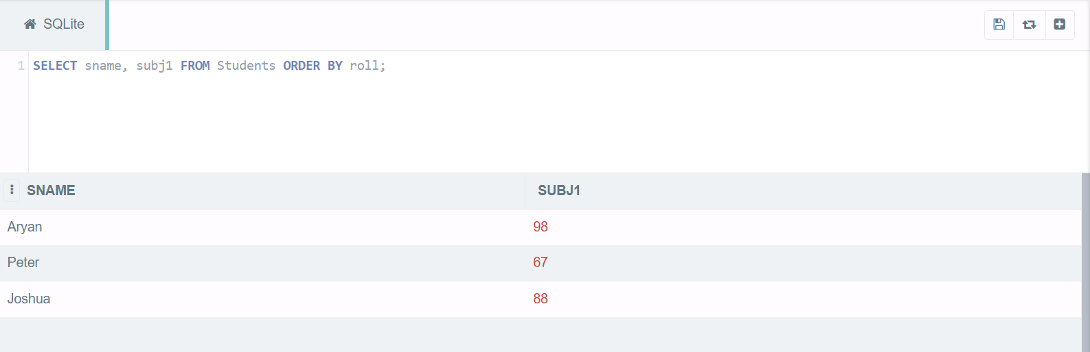

Example 2:

Code-

CREATE TABLE Employees(id INT, name VARCHAR(30), salary INT); (Created table Employees)

INSERT into Employees

VALUES(234, "Brijesh Mohan", 30000), (380, "Kartik Saluja", 50000), (871, "Yash Raj", 20000), (694, "Abdul", 90000); (Inserted 4 records into Employees)

SELECT name, salary FROM Employees ORDER BY id; (grouped to all the records in the relation together for each and every value of a specific key(s) and then displayed them for a selected set of fields in the relation)

Output-

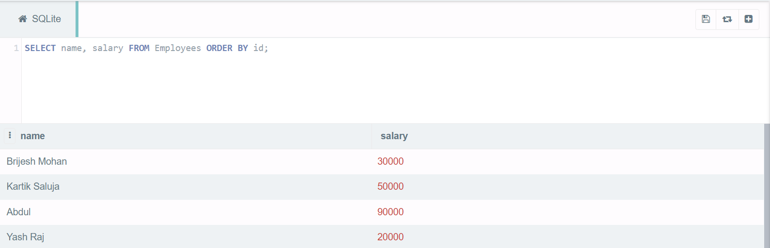

1. **JOIN using SELECT – FROM- WHERE: This query is used to display a set of fields from two**

**relations by matching a common field in them.**

**Syntax: SELECT a set of fields from both relations FROM relation_1, relation_2 WHERE**

**relation_1.field_x = relation_2.field_y ;**

**Example: SQL> SELECT * FROM FACULTIES, STUDENT WHERE STUDENT.SNAME =**

**FACULTIES.FNAME**

Example 1:

Code-

CREATE TABLE Students(ID INT, SNAME VARCHAR(30), SUBJ1 INT); (Created table Students)

INSERT INTO Students

VALUES(22, "Harsh", 80), (49, "Punit", 97), (56, "Prakash", 45); (Inserted 3 records into Students)

CREATE TABLE Faculties(FID INT, FNAME VARCHAR(30), DEPT VARCHAR(30)); (Created table Faculties)

INSERT INTO Faculties

VALUES(279, "Punit", "Computer Science"), (456, "Kunal", "Electrical"), (780, "Adarsh", "Civil"); (Inserted 3 records into Faculties)

SELECT * FROM Students, Faculties WHERE Students.SNAME=Faculties.FNAME; (Displayed a set of fields from two relations by matching a common field in them)

Output-

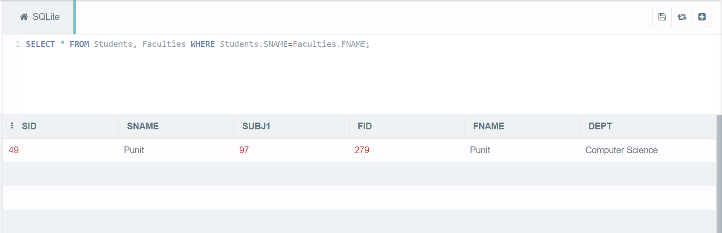

Example 2:

Code-

CREATE TABLE Finance(id INT, name VARCHAR(30), salary INT); (Created table Finance)

INSERT into Finance

VALUES(491, "Kapil", 40000), (561, "Sunil", 95000), (211, "Hardik", 20000), (766, "Suresh", 75000); (Inserted 4 records into Finance)

CREATE TABLE HR(id INT, name VARCHAR(30), salary INT); (Created table HR)

INSERT into HR

VALUES(791, "Ben", 40000), (594, "Steve", 15000), (559, "Ashish", 80000), (896, "Akash", 75000); (Inserted 4 records into HR)

SELECT * FROM Finance, HR WHERE Finance.salary=HR.salary; (Displayed a set of fields from two relations by matching a common field in them)

Output-

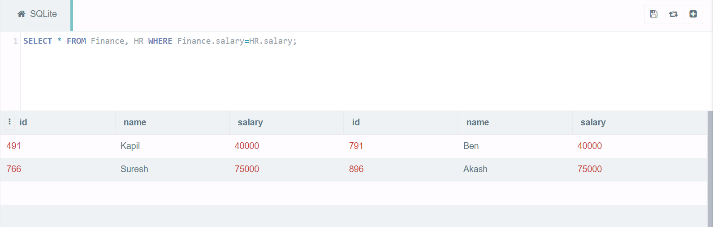

1. **JOIN using SELECT –FROM- WHERE- ORDER BY: This query is used to display a set of fields from**

**two relations by matching a common field in them in an ordered manner based on some fields.**

**Syntax: SELECT a set of fields from both relations FROM relation_1, relation_2 WHERE**

**relation_1.field_x = relation_2.field_y ORDER BY field_z;**

**Example: SQL> SELECT * FROM FACULTIES, STUDENT WHERE STUDENT.SNAME =**

**FACULTIES.FNAME ORDER BY ROLL**

Example 1:

Code-

CREATE TABLE Students(ROLL INT, SNAME VARCHAR(30), SUBJ1 INT); (Created table Students)

INSERT INTO Students

VALUES(12, "Aryan", 89), (2, "Billy", 77), (96, "Pramod", 99), (44, "Kane", 100); (Inserted 4 records into Students)

CREATE TABLE Faculties(ID INT, FNAME VARCHAR(30), DEPT VARCHAR(30)); (Created table Faculties)

INSERT INTO Faculties

VALUES(387, "Billy", "Computer Science"), (900, "Kane", "Electrical"), (190, "Pramod", "Civil"), (500, "Arjun", "Mechanical"); (Inserted 4 records into Faculties)

SELECT * FROM Students, Faculties WHERE Students.SNAME=Faculties.FNAME ORDER BY roll; (Displayed display a set of fields from two relations by matching a common field in them in an ordered manner based on some fields)

Output-

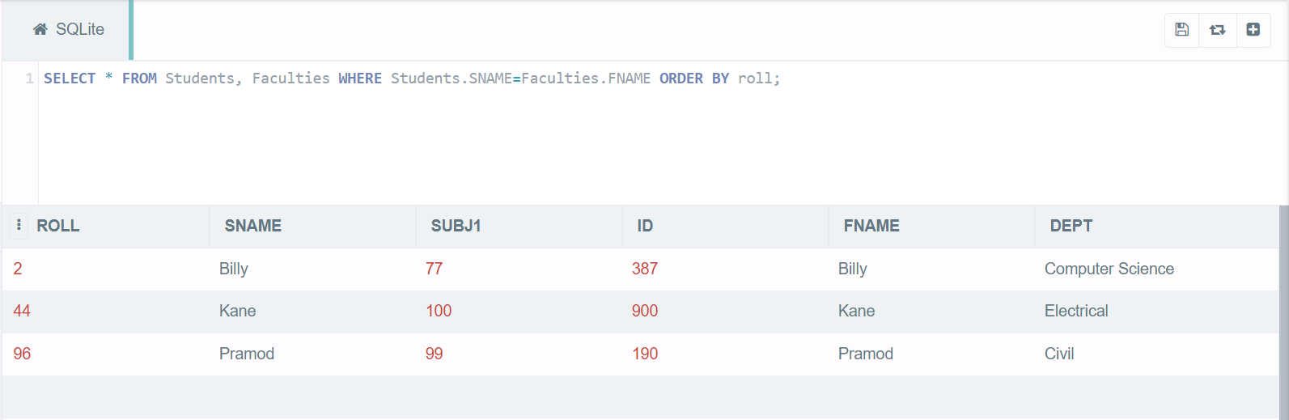

Example 2:

Code-

CREATE TABLE College1(location1 VARCHAR(20), name1 VARCHAR(30), salary1 INT);(Created table College1)

INSERT into College1

VALUES("Bhubaneswar", "Prof. Raj Sharma", 100000), ("Delhi", "Prof. Harish Gupta", 50000), ("Mumbai", "Prof. Sachin Agrawal", 150000); (Inserted 3 records into College1)

CREATE TABLE College2(location2 VARCHAR(30), name2 VARCHAR(30), salary2 INT);(Created table College2)

INSERT into College2

VALUES("Bhubaneswar", "Prof. Lalu Prasad", 60000), ("Mumbai", "Prof. Shubham Tiwari", 200000), ("Delhi", "Prof. Manish Goyal", 30000); (Inserted 3 records into College2)

SELECT * FROM College1, College2 WHERE College1.location1=College2.location2 ORDER BY salary1;

(Displayed display a set of fields from two relations by matching a common field in them in an ordered manner based on some fields)

Output-

